## REGRESSION EXERCISE

1. **Predictive Modeling Using Regression**
   1. Return to the Chapter 3 Organics diagram in the **My Project**. Use the StatExplore tool on the **ORGANICS** data source.
      1. First **StatExplore** node is connected to the **ORGANICS** node.
      2. StatExplorer node results is generated

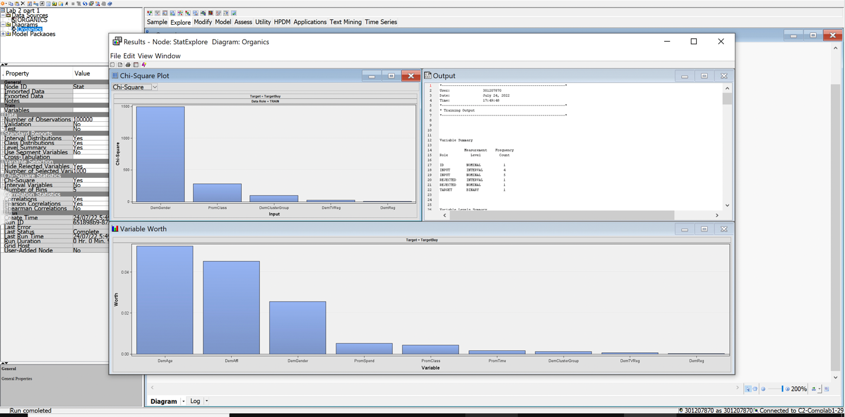

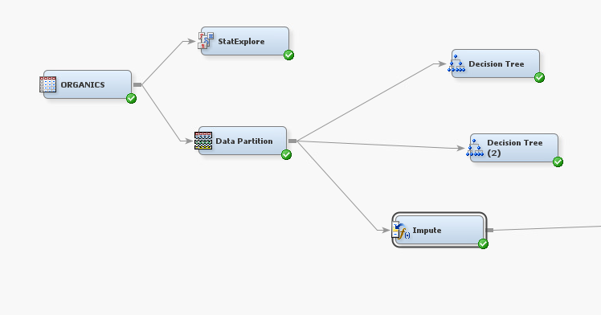

* 1. In-order to prepare for regression, missing values are imputed? Why do you think we should impute?

We should impute the data because this function helps in replacing the missing values in a data so that we don’t get an irregular data.

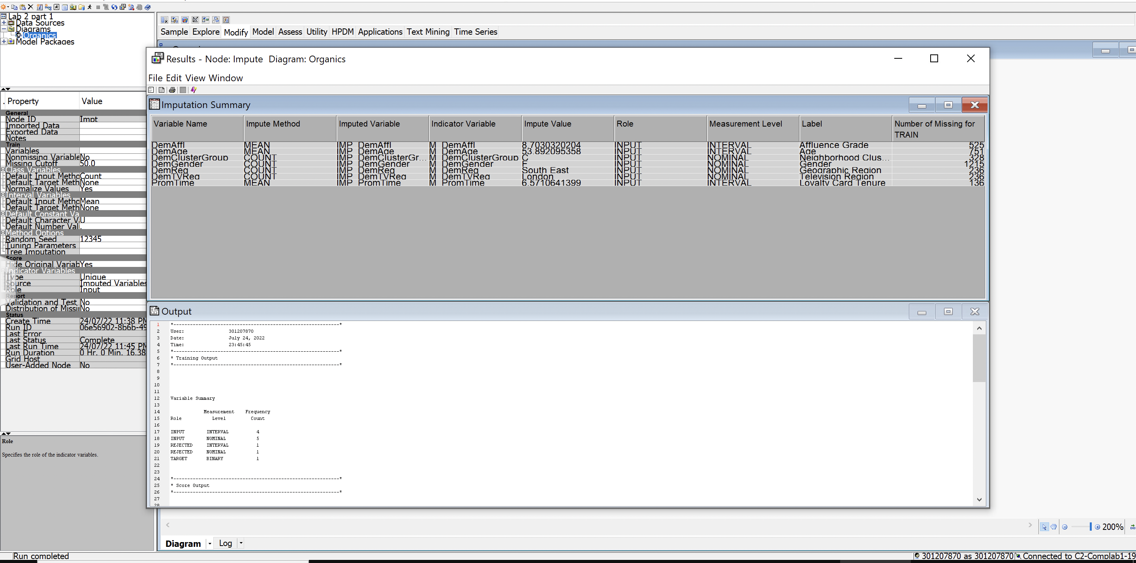

* 1. What changed after imputing?

The data had a lot of missing values, which are now filled up by the Impute function, by calculating the mean or count of the variables with missing values. Now the data is ready to be analyzed properly.

* 1. Add an **Impute** node from the **Modify** tab into the diagram and connect it to the **Data Partition** node. Set the node to impute **U** for unknown class variable values and the overall mean for unknown interval variable values. Create imputation indicators for all imputed inputs.
  2. Add a **Regression** node to the diagram and connect it to the **Impute** node. Choose stepwise as the selection model and the validation error as the selection criterion.
  3. Choose stepwise as the selection model and the validation error as the selection criterion.

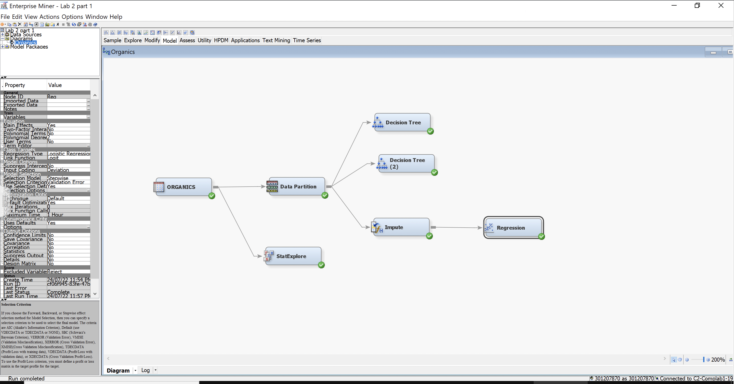

* 1. Run the Regression node and view the results. Maximize the Effect Plot.
  2. Which variables are included in the final model? Which variables are important in this model? What is the validation ASE?

The variables included in the final model are IMP_DemAge, IMP_DemGender and IMP_DemAffl.

IMP_DemGender seems to be important in this model as the Odds Ratio Estimates mention Females and Males are likely to buy the organic products. Average Squared error (ASE) is 0.13

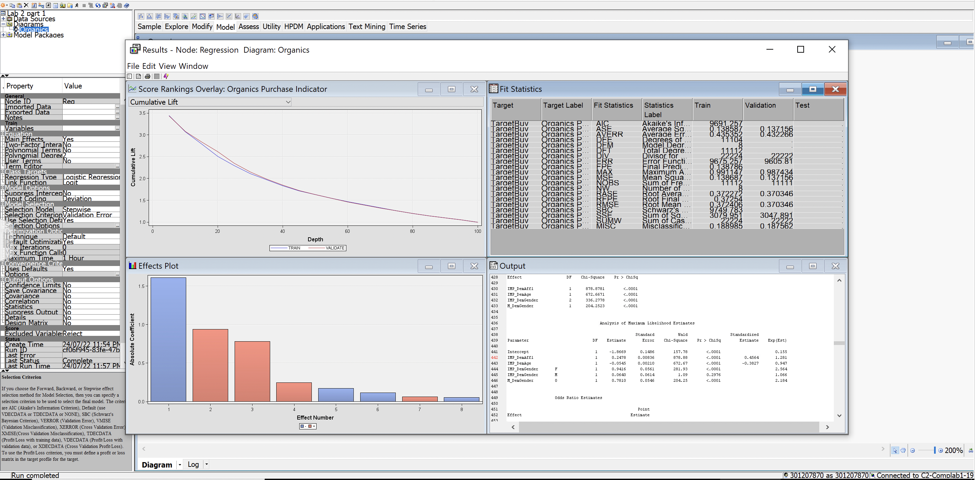

1. Go to line 664 in the Output window.

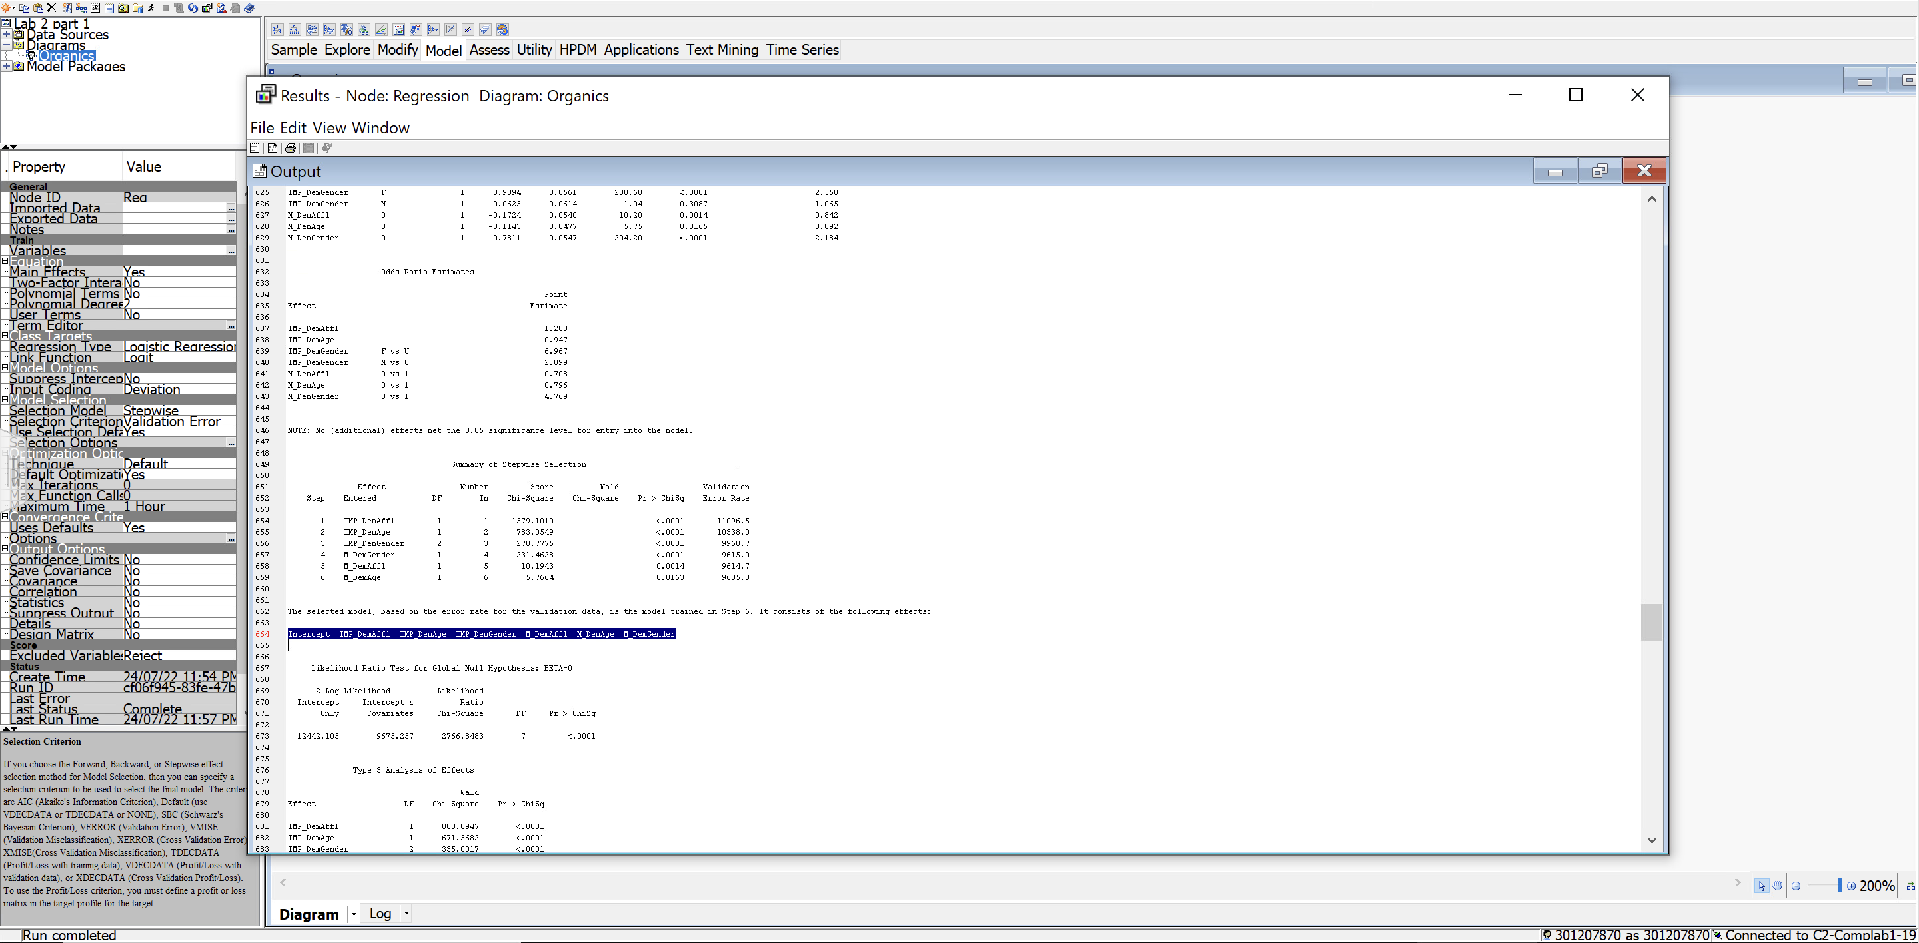

1. The odds ratios indicate the effect that each input has on the logit score.

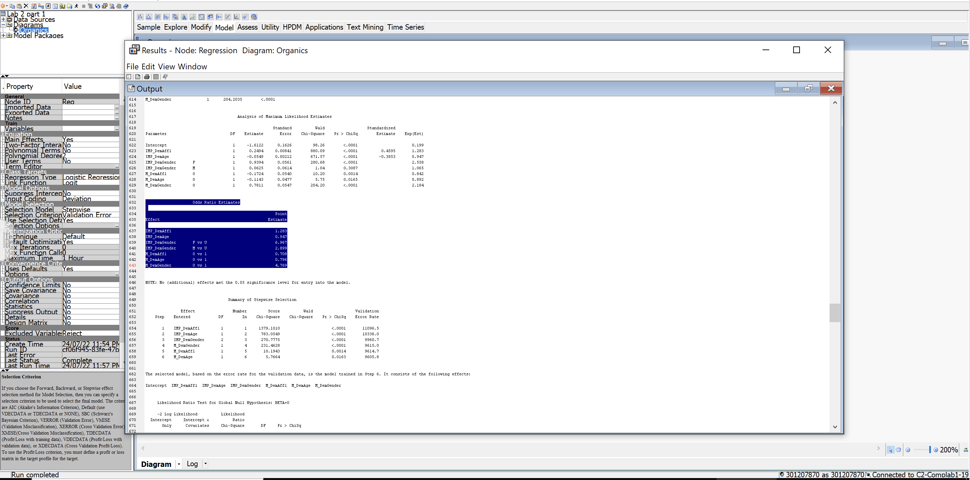

1. Interpret the odds ratio estimate:

DemAffl point estimate is 1.283, which indicates that there is a positive 28% likelihood of buying the organic products. DemAge is 0.947 means there is a negative 5.4% likelihood of buying the organic products. For females, there is a positive 6 times more likely to buy an organic product whereas males are twice as likely to buy them.

1. The validation ASE is given in the Fit Statistics window.

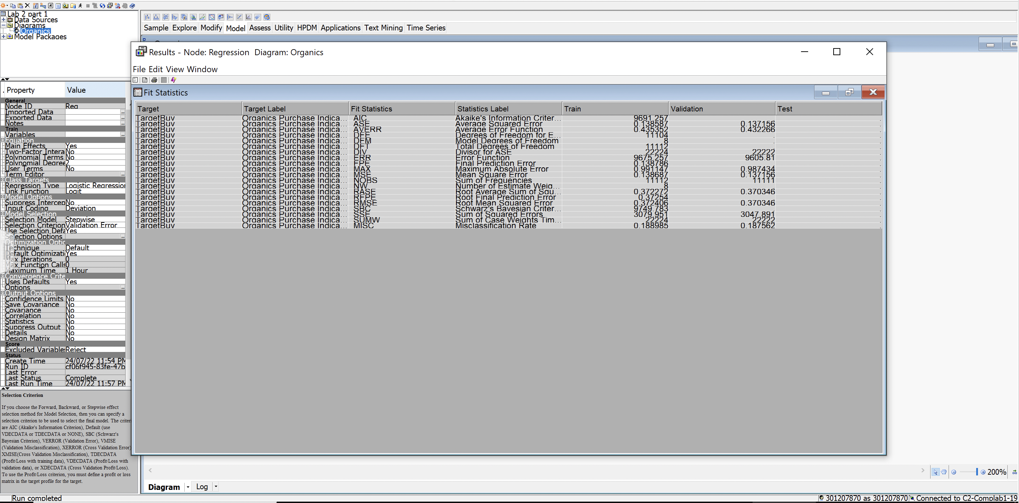

**PART 2**

* 1. In preparation for regression, are any transformations of the data warranted? Why or why not?

Regression depends on the skewness or outliers of the data. The regression line might be different due to skewness of the data or present outliers. To remove these and get an efficient analysis, we transform the data by using a transformation function.

* + 1. Open the Variables window of the Regression node. Select the imputed interval inputs.
    2. Select **Explore**. The Explore window appears.

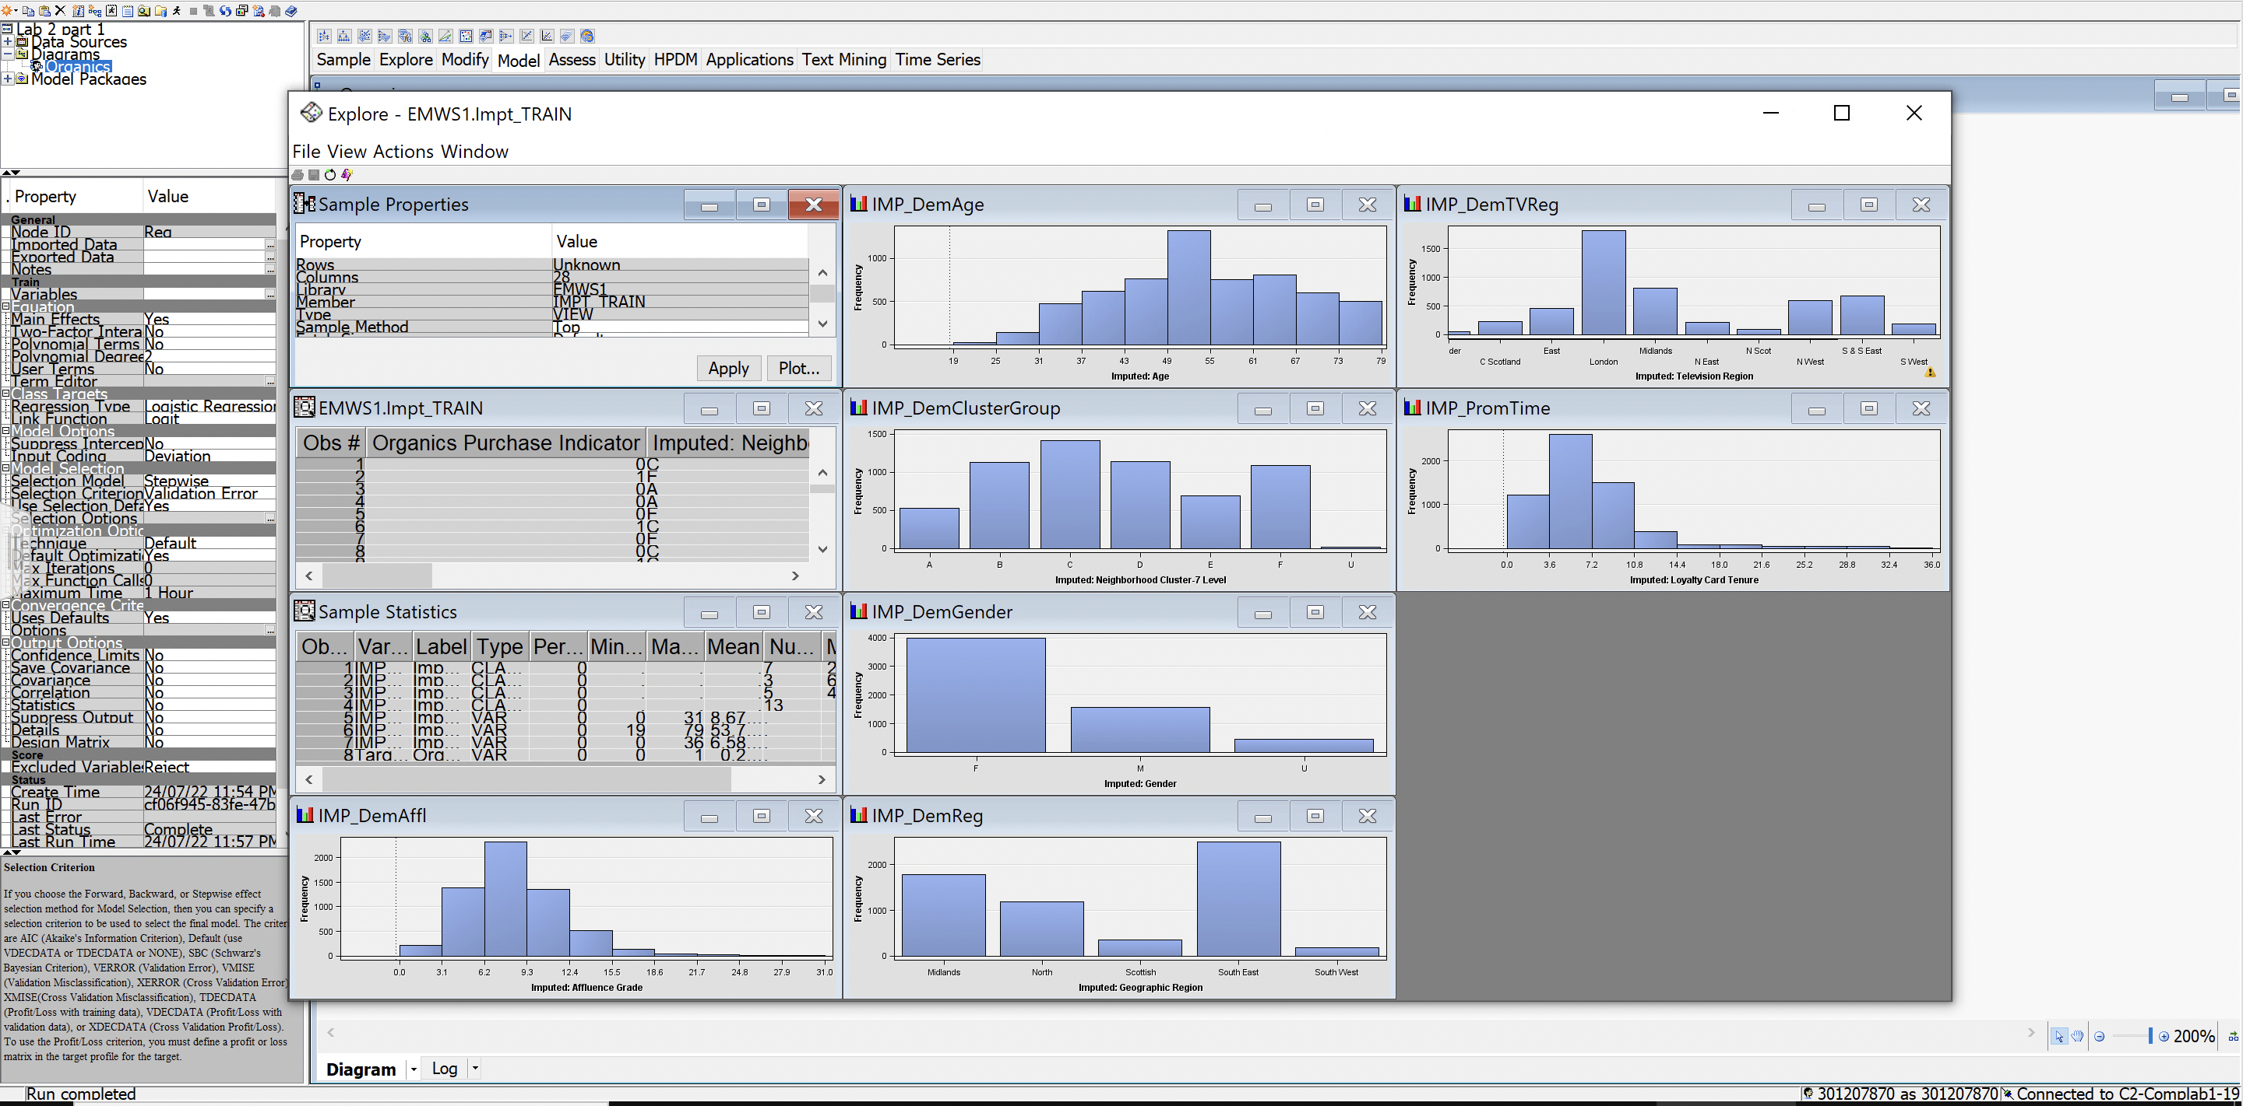

* 1. Both Card Tenure and Affluence Grade have moderately skewed distributions. Applying a log transformation to these inputs might improve the model fit.

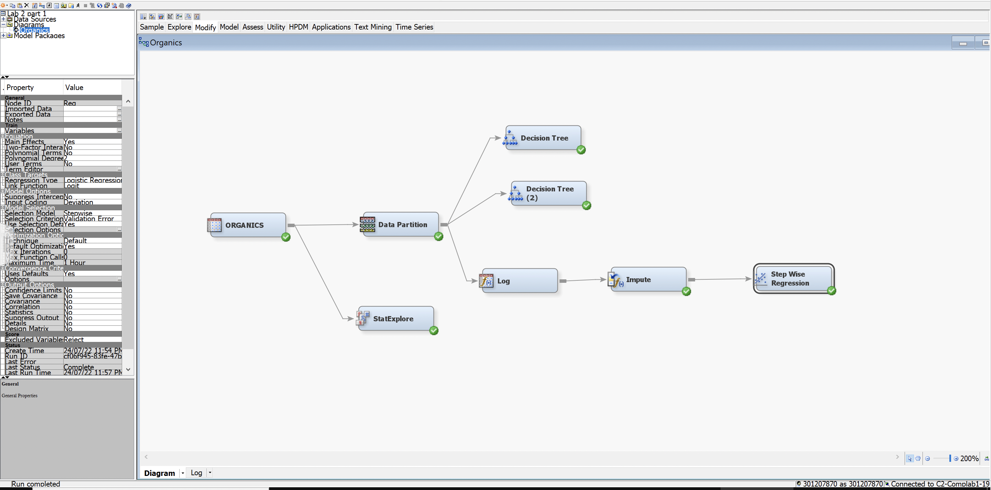

* 1. Disconnect the **Impute** node from the **Data Partition** node.
  2. Add a **Transform Variables** node from the **Modify tab** to the diagram and connect it to the   
     **Data Partition** node.
  3. Connect the **Transform Variables** node to the **Impute** node.
  4. Apply a log transformation to the DemAffl and PromTime inputs.
     1. Open the Variables window of the Transform Variables node.
     2. Select **Method** ⇨ **Log** for the DemAffl and PromTime inputs. Select **OK** to close the Variables window.

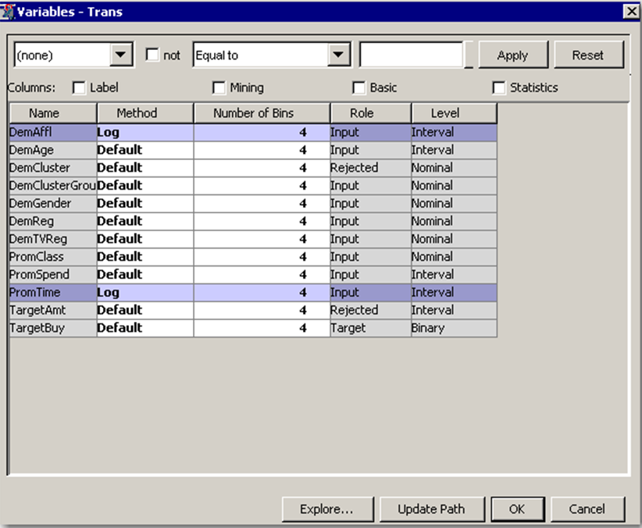

* 1. Run the **Transform Variables** node. Explore the exported training data. Did the transformations result in less skewed distributions?
     1. The easiest way to explore the created inputs is to open the Variables window in the subsequent Impute node. Make sure that you update the Impute node before opening its Variables window.
     2. With the **LOG_DemAffl** and **LOG_PromTime** inputs selected, select **Explore**.

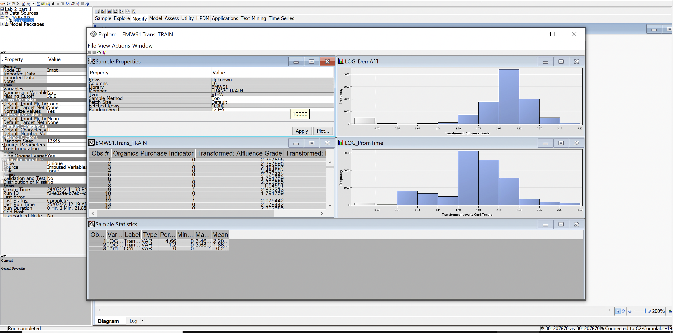

**The distributions are nicely symmetric.**

* 1. Rerun the **Regression** node. Do the selected variables change? How about the validation ASE?

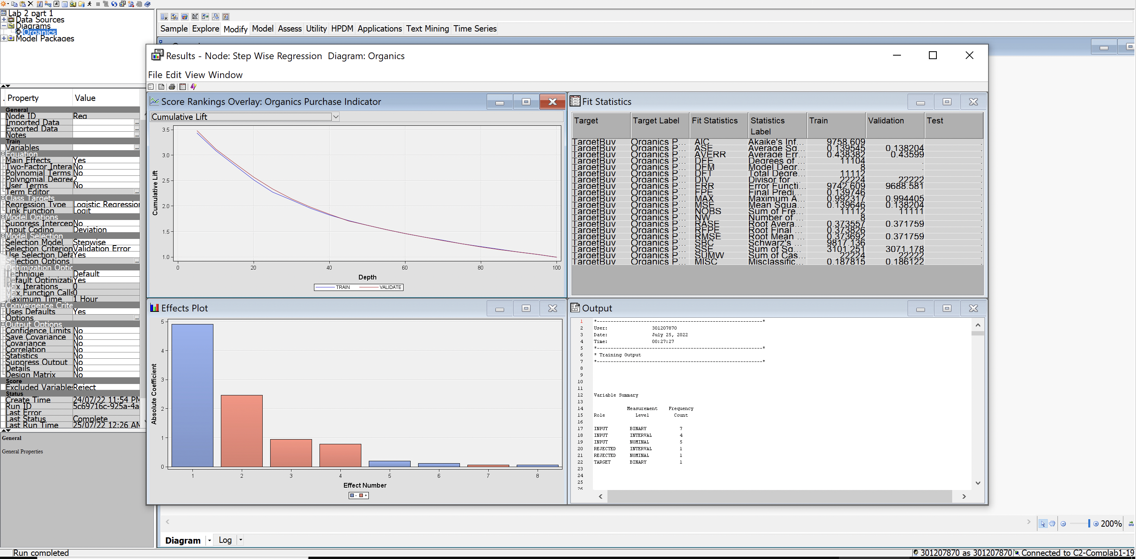

* 1. Go to line 664 of the Output window.

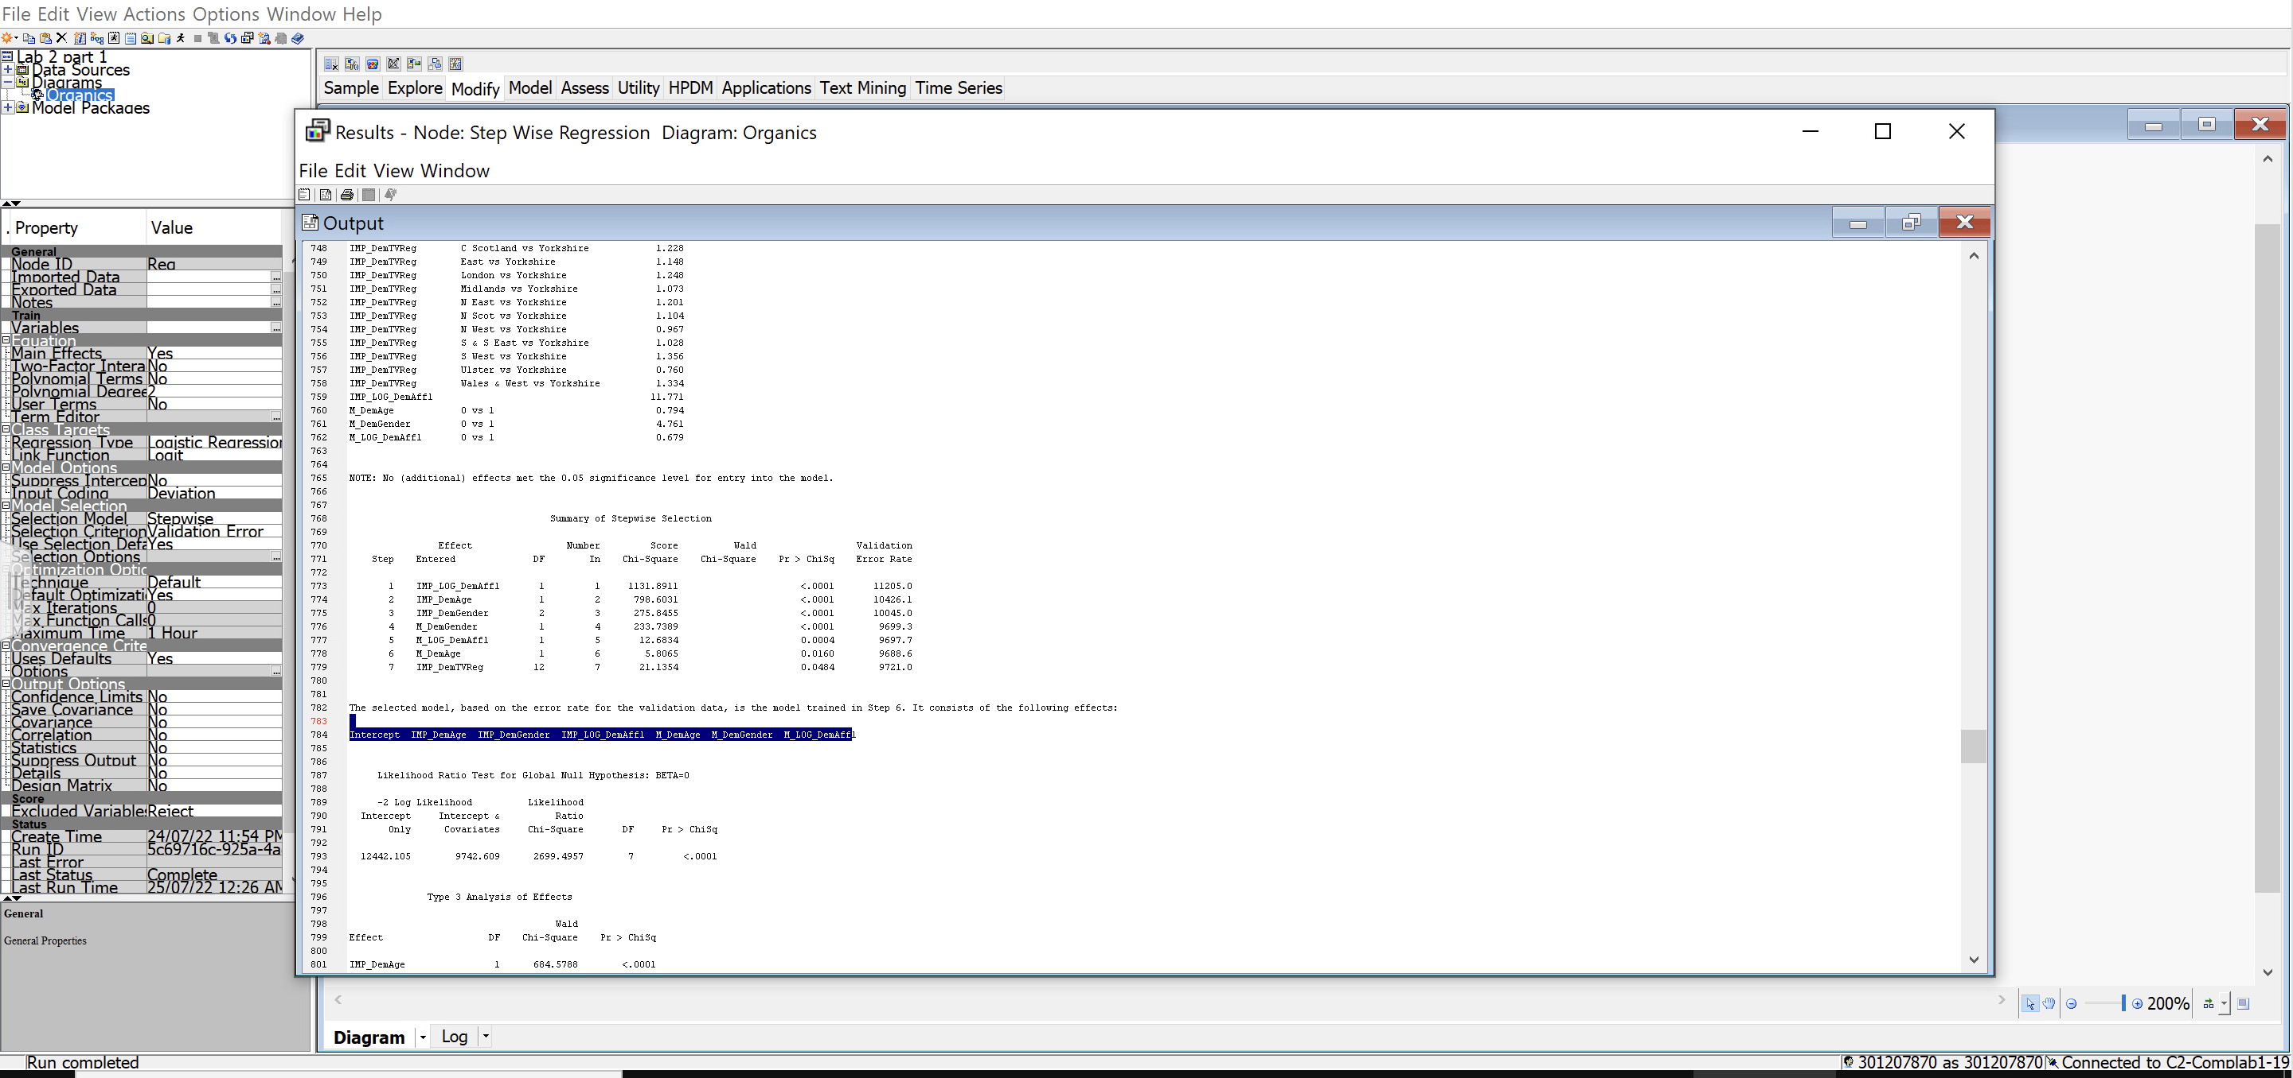

* + 1. Apparently the log transformation actually increased the validation ASE slightly.

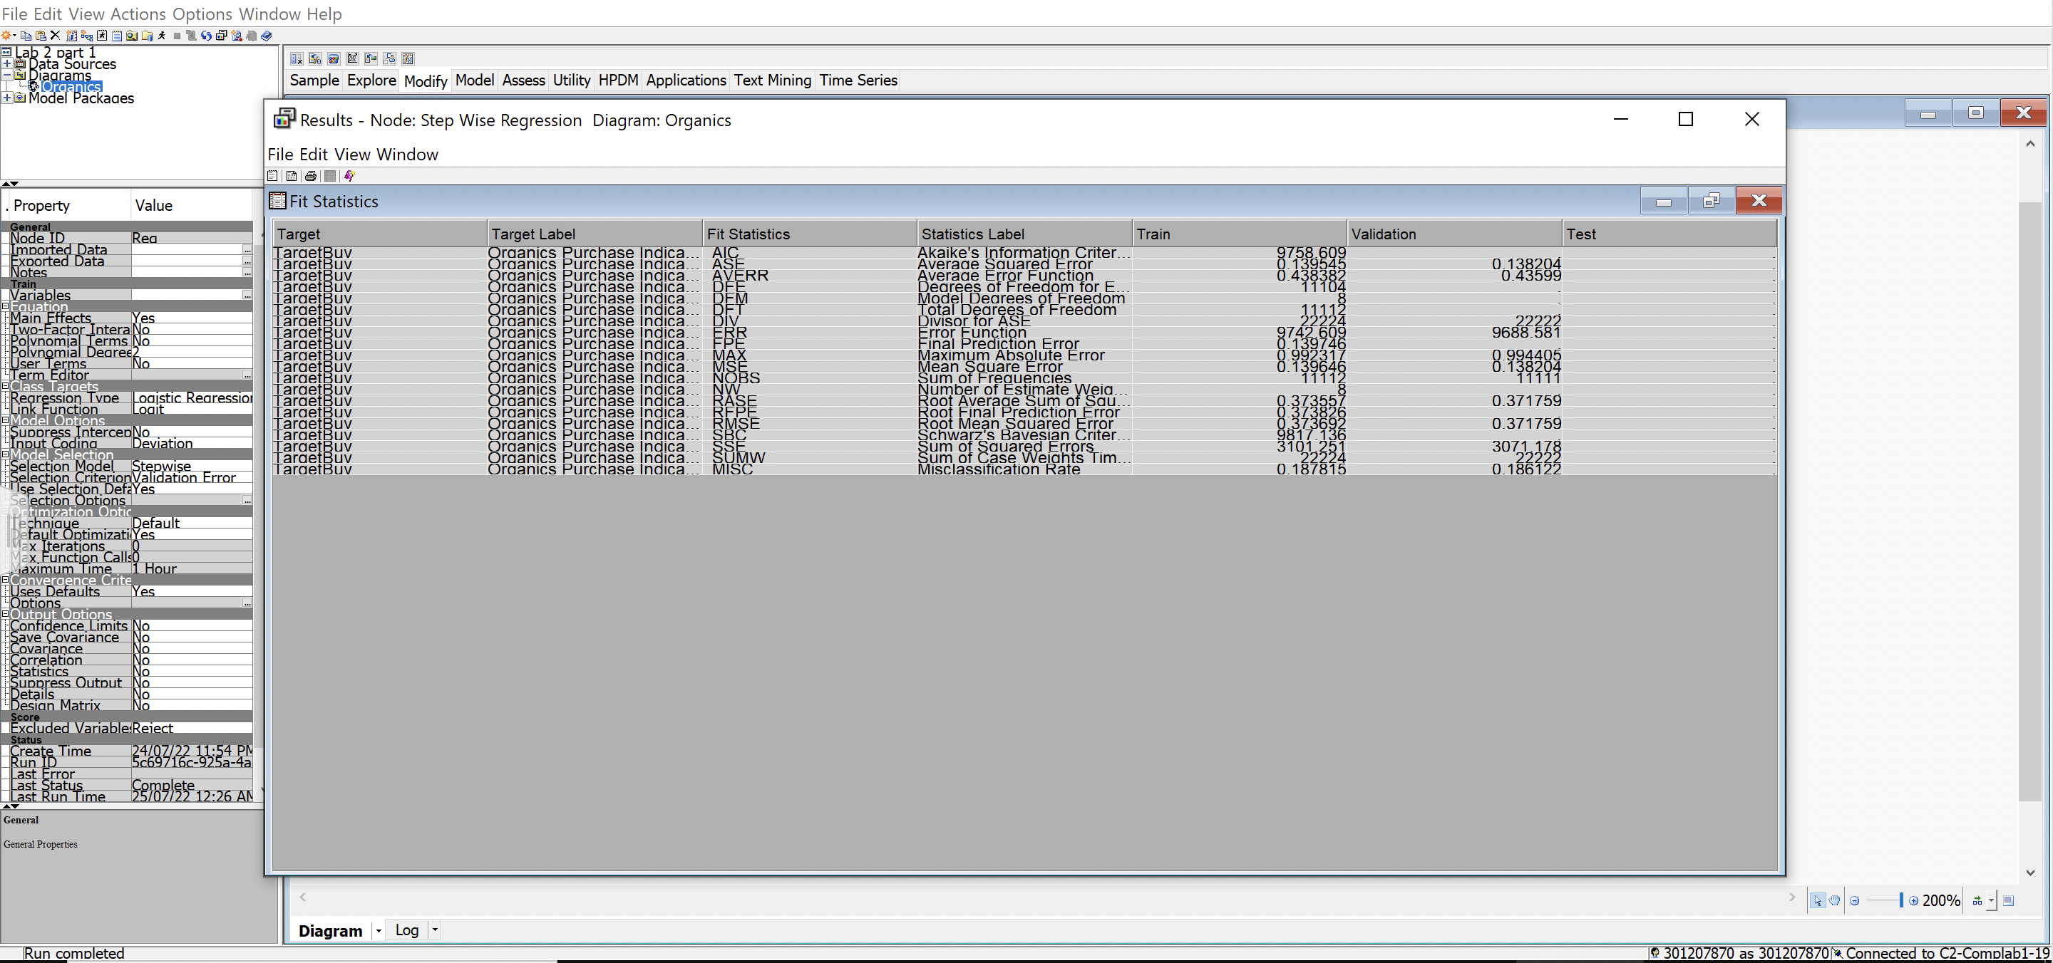

* 1. Create a full second-degree polynomial model. How does the validation average squared error for the polynomial model compare to the original model?
     1. Add another Regression node to the diagram and rename it **Polynomial Regression**.
     2. Make the indicated changes to the Polynomial Regression Properties panel and run the node.
     3. Go to line 1598 of the results output window.

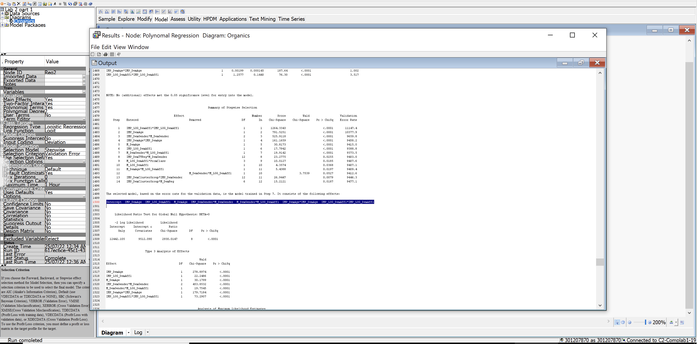

1. The polynomial regression node adds additional interaction terms.
2. Examine the Fit Statistics window.

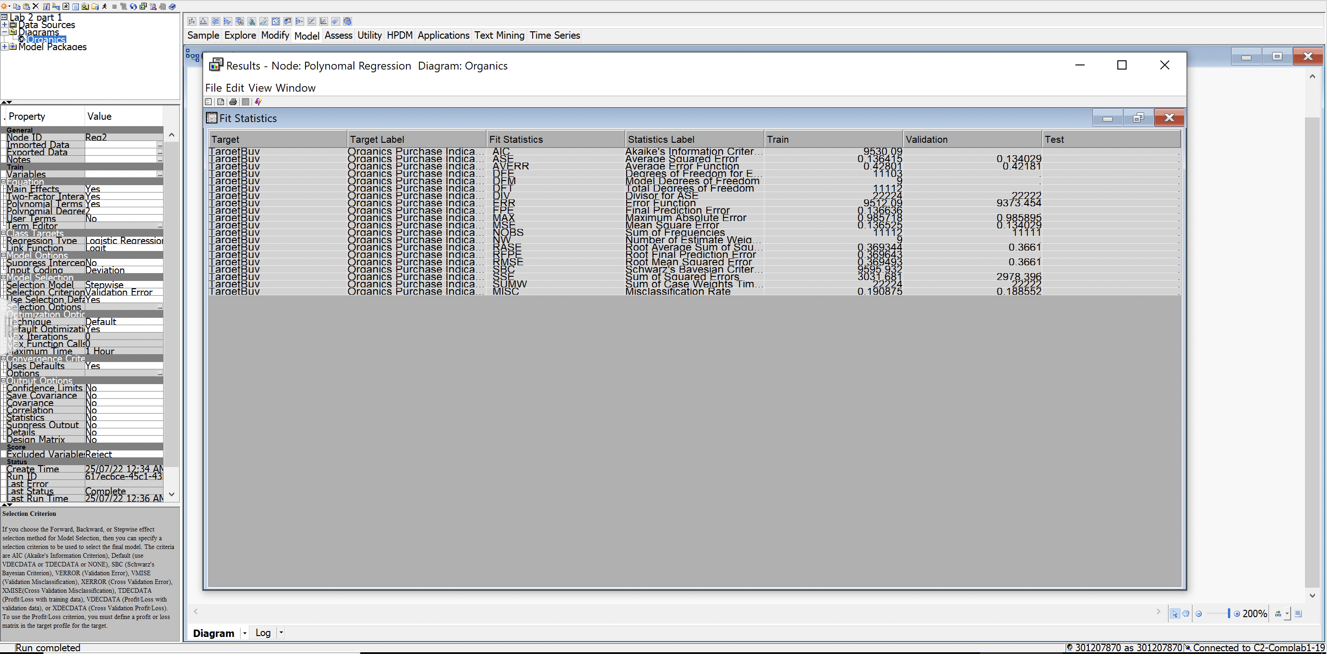

k) In your words, describe what did you do in this assignment and why you had to do each of these steps? Plus, how would you describe the IV’s that have an impact on the DV.

In this assignment, I performed regression function on the given dataset and had to run each of these steps to identify the missing values, so that those data variables could be imputed to have a better analysis of the data, I also rejected variables that were not important in relation to the analysis and cleaned up data for an easy understanding of the analysis.

The dependent variable is Age as that was the first variable that split the tree. It affects the other independent variables like Gender and Affluence Grade.